search engine marketing

Assignment (SEM)

Sky Asia tours – campaign setup

Name : Josva Rochi .R
Email: josva6438@gmail. Com

Introduction:
- A short paragraph about the objective:
This google Ads search campaign was created for sky Asia tours with goal of driving website traffic and travel inquiries.
The campaign includes 3 ad groups with tailored keywords, ads, and ad extensions.

Here :

Created google Ads accounts in the expert mode.

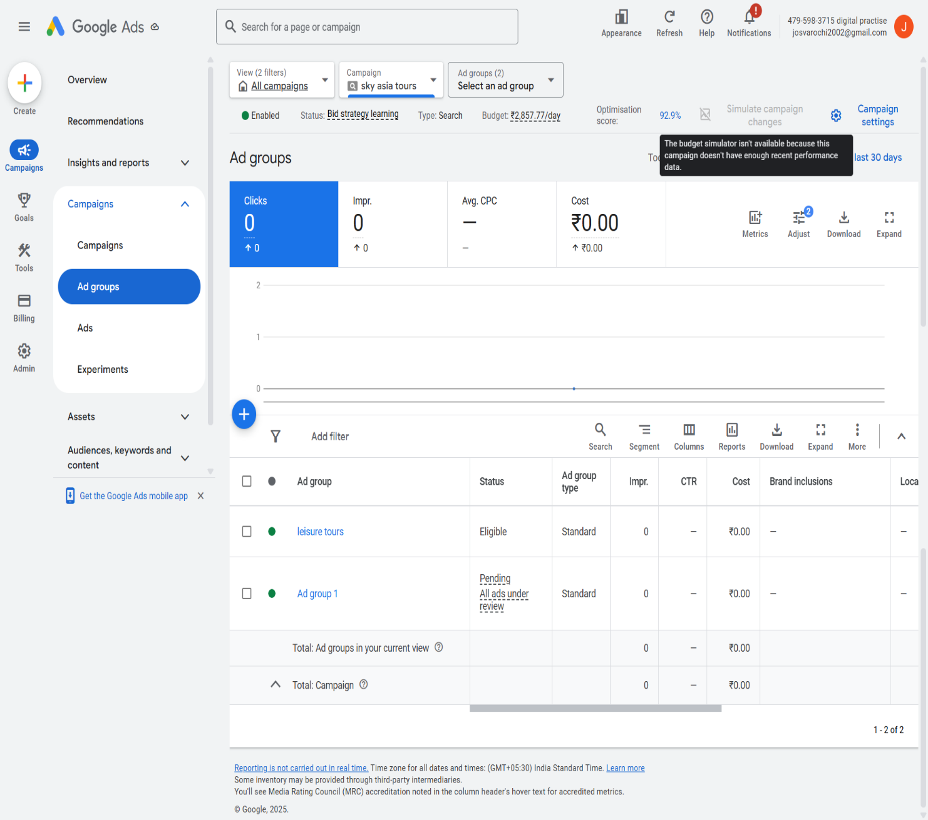

Sky Asia tours campaign;

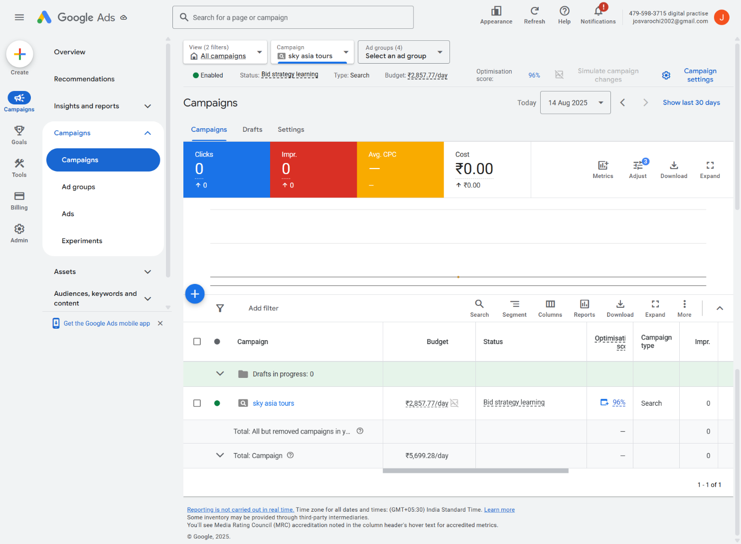

Here’s an Ad group screenshots,

- Leisure tours ad group

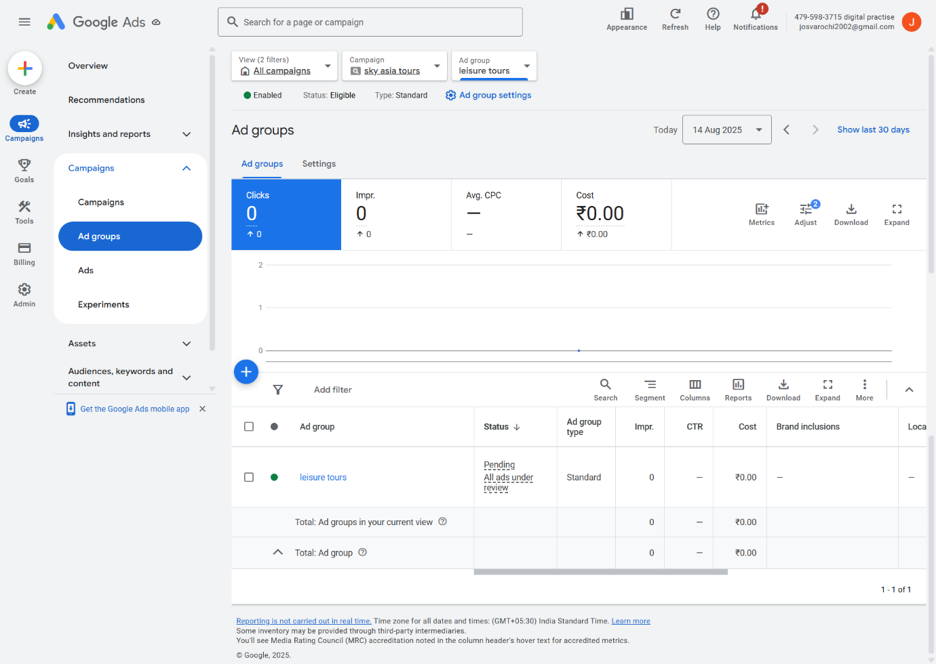

2.luxury tours ad group

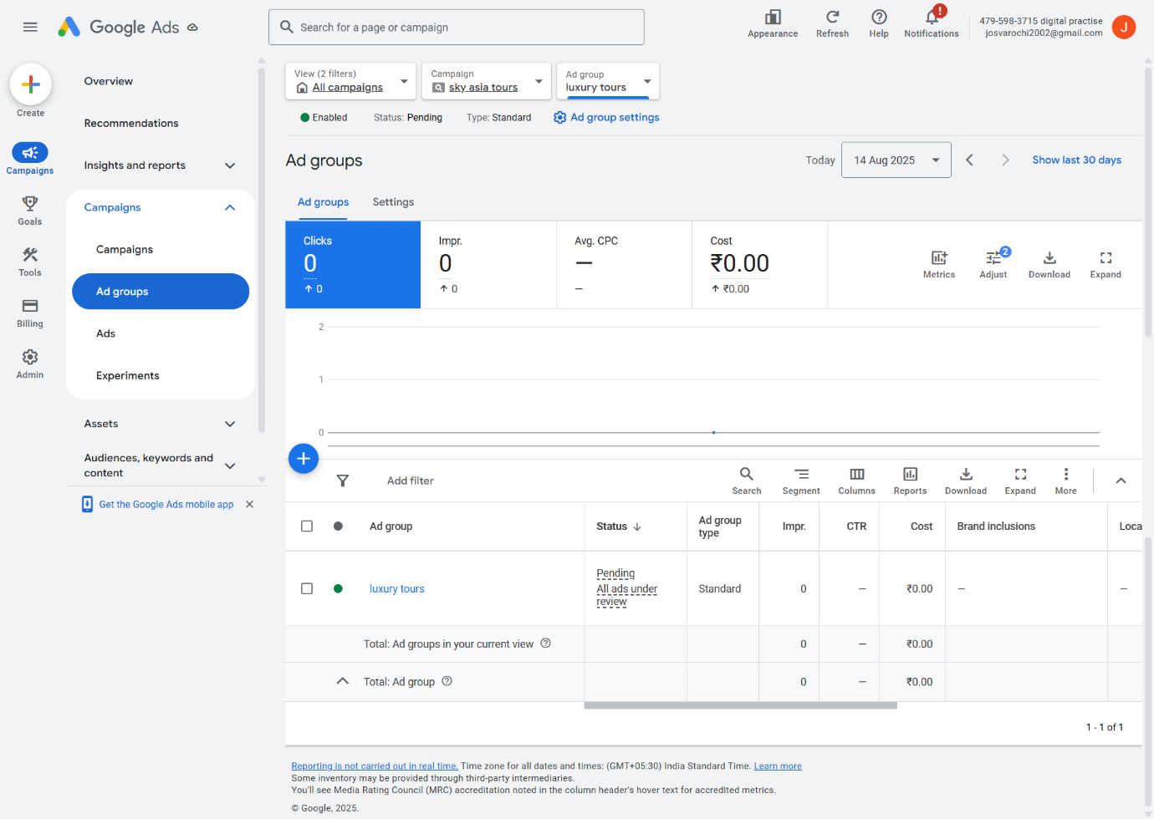

Unique experience ad group,
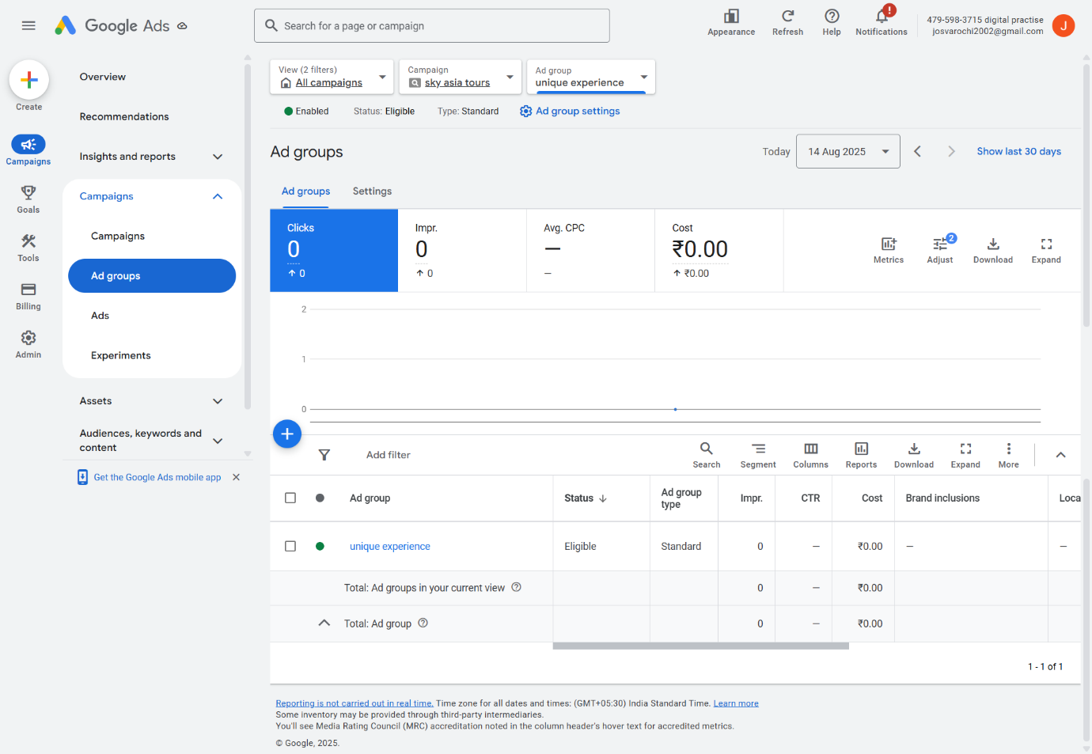

Keywords for (per Ad group)

Ad group 1: leisure tours

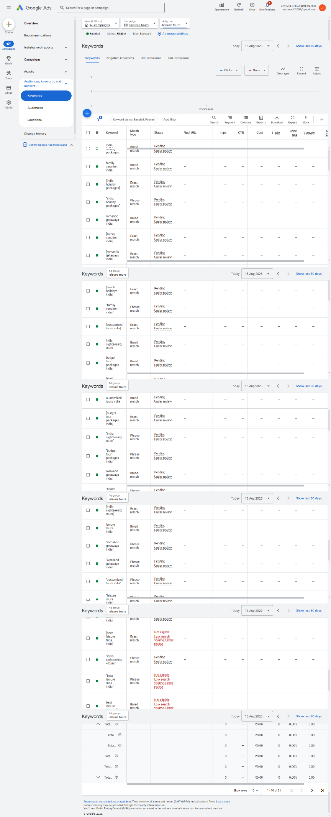
Ad group 2: luxury tours
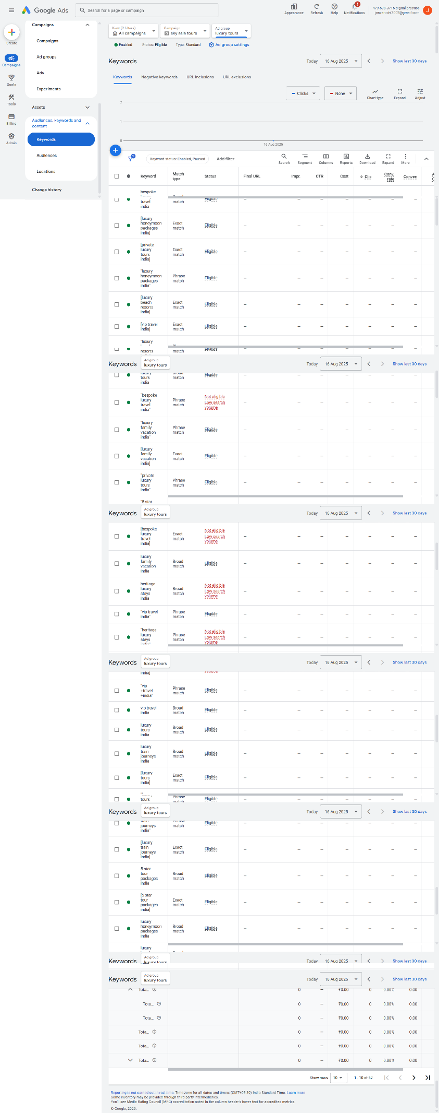

Ad group 3: unique experience
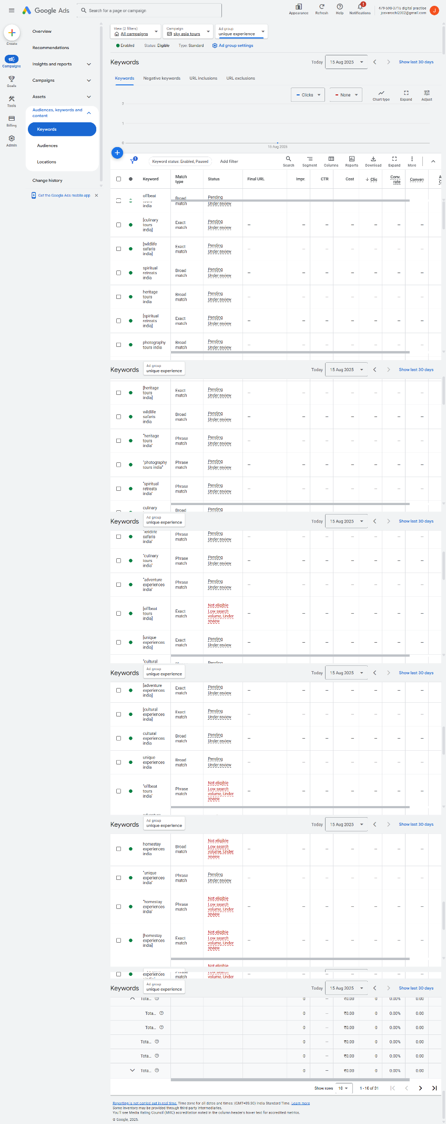

Assets (extensions)
Site links screenshot.

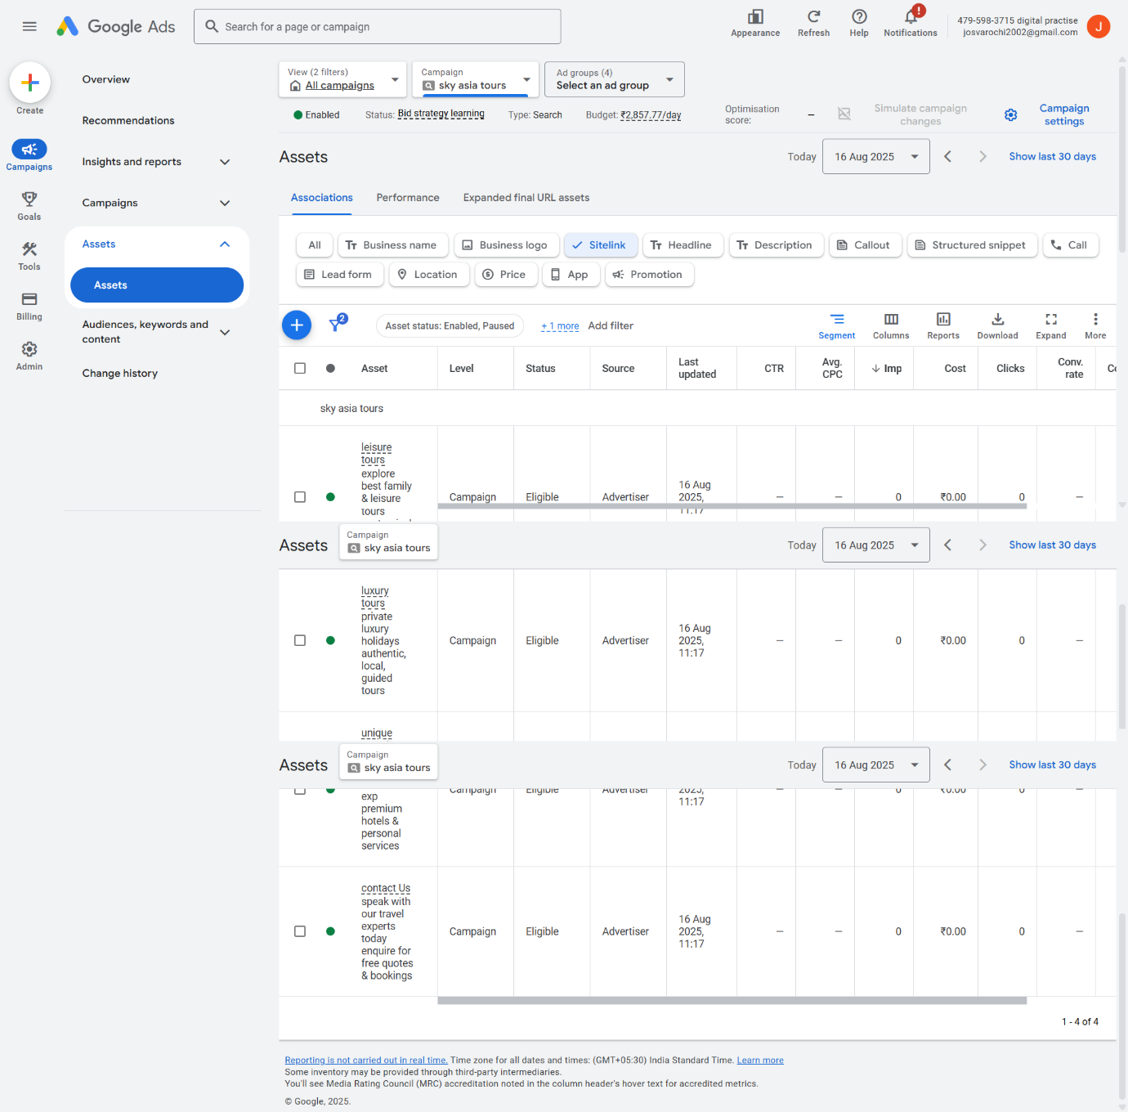

Callouts screenshot.

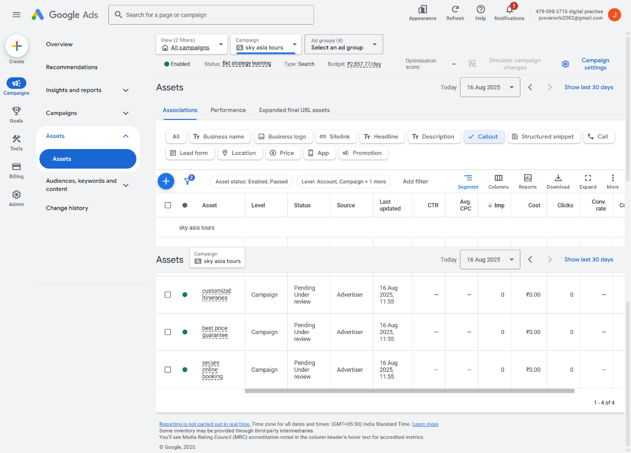

Campaign settings (location, budget, bidding) screenshot.

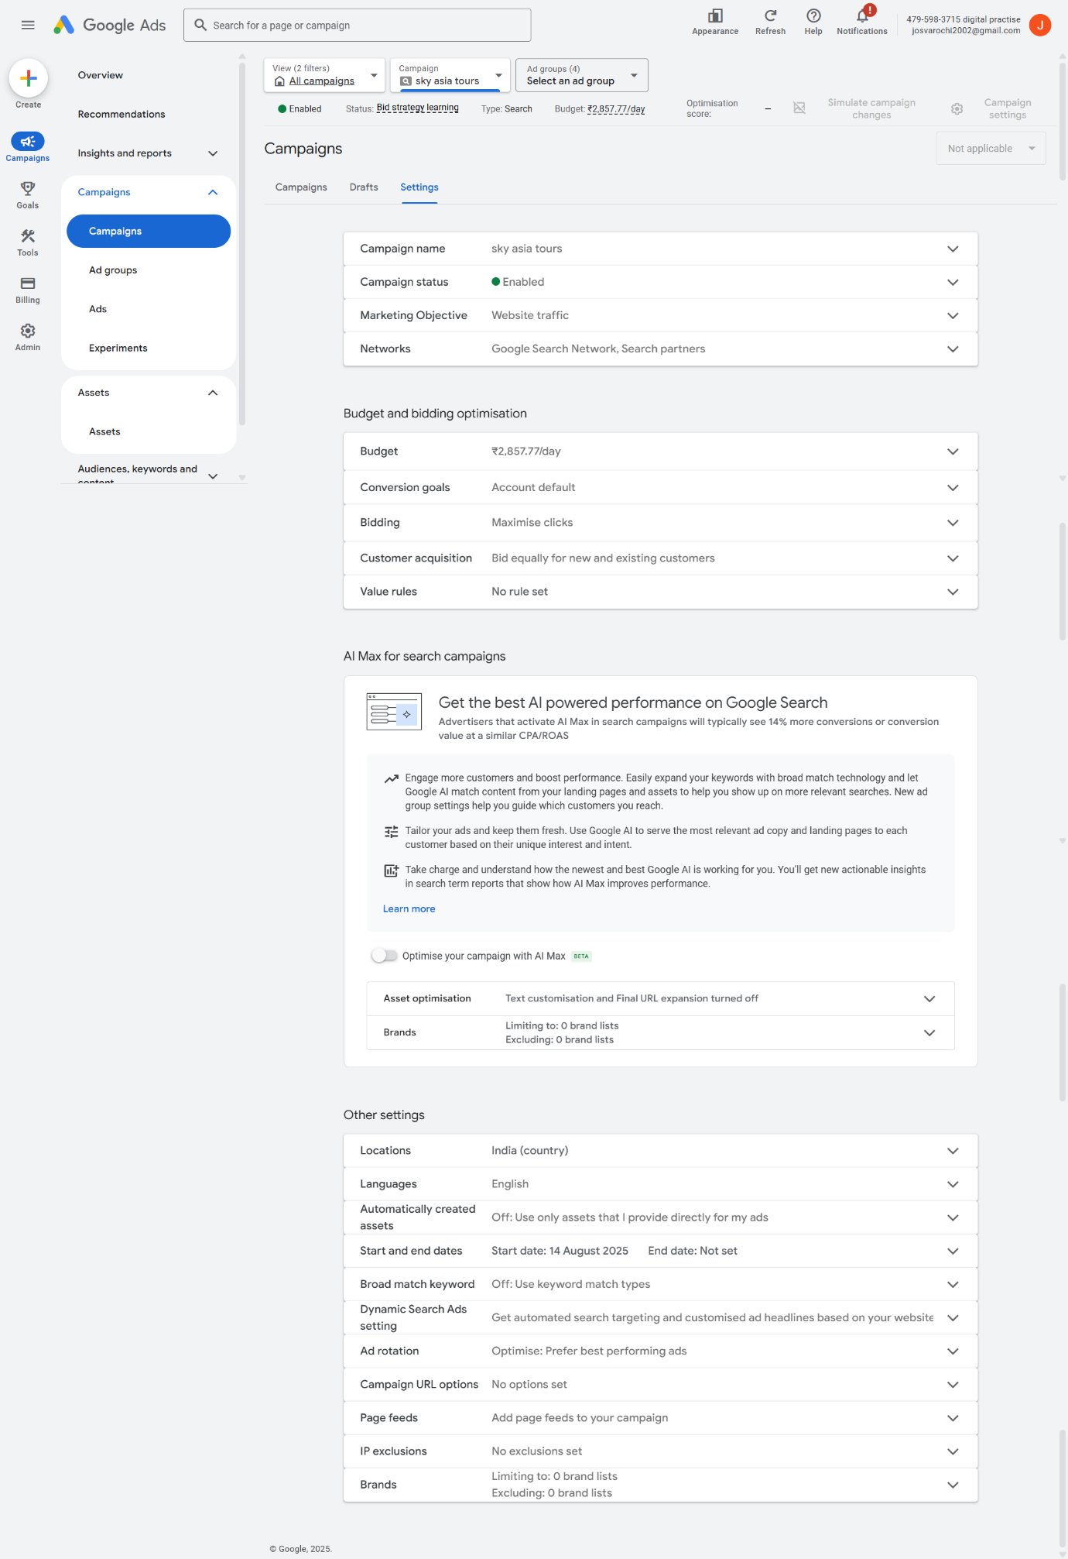

Conclusion :
The Sky Asia tours SEM campaign is structured with clear objectives, targeted keywords, engaging ads, ads, and supportive asssets. This setup ensures maximum visibility and relevance for this assignment and the screenshot has been shared as for this assignment.

